Calculate Delayed Arrival Time
Platform: LeetCode
Language: C
Module 1, Question 4

Problem Link

https://leetcode.com/problems/calculate-delayed-arrival-time/

Problem Statement
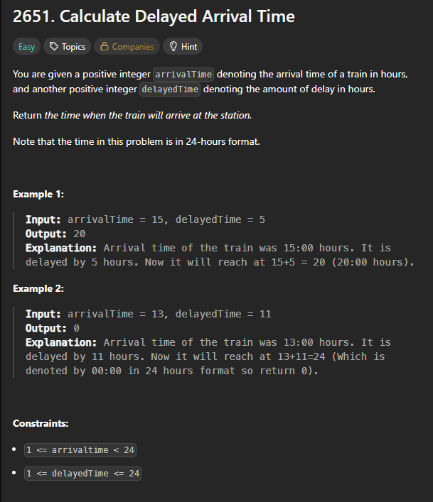

C Code
int findDelayedArrivalTime(int arrivalTime, int delayedTime) {
return (arrivalTime + delayedTime) % 24;
}

Screenshot of Successful Submission



